Quick Job System — Job Posting Portal
Spring Boot | Spring Web | Thymeleaf | JPA/Hibernate | H2 | REST API | Spring Security

Team: Frin, Samuel, Aanand

1. Introduction
This project is the Quick Job System: a job posting portal built with Spring Boot. Employers publish jobs; workers browse, apply, and message employers through application threads. An administrator can manage users and listings. The browser UI uses Thymeleaf; JSON clients use REST endpoints secured with HTTP Basic authentication (no JWT in this implementation).

2. Technologies Used
Framework: Spring Boot 4.x (Java 21)
Web: Spring Web MVC; REST controllers (@RestController); WebFlux starter present
Persistence: Spring Data JPA, Hibernate; H2 file database (./data/quickjobdb)
Security: Spring Security — form login for web UI; HTTP Basic (stateless) for /api/**
View layer: Thymeleaf (+ Spring Security extras)
Build: Maven; API testing: Postman or curl

3. Business Problem
Informal hiring for quick or short-term work is often fragmented: job details live in spreadsheets or group chats, applicants are hard to compare, and follow-up messages are easy to lose. Employers need a simple workflow to post roles and review interest; workers need structured applications and messaging tied to each opportunity.

4. Proposed Solution
The system models job posts with applications (pending, approved, rejected, cancelled). Employers review applications; workers apply once per job and can exchange messages on an application. REST APIs expose jobs, applications, messages, and admin user operations; the web app uses server-side sessions and role-based routes for EMPLOYER, WORKER, and ADMIN.

5. Authentication & Security
Web: users sign in with the form at /login (POST /login); passwords stored with BCrypt.
API: /api/jobs and /api/jobs/{id} are public; other /api/** routes require HTTP Basic credentials (Authorization: Basic …). CSRF is disabled for APIs; API sessions are stateless.
Roles: EMPLOYER (job CRUD, application approve/reject), WORKER (browse/apply, cancel own applications), ADMIN (user list, job cleanup).

6. Functional Modules
Registration & authentication (web form; role at signup)
Employer dashboard: post, edit, close, delete jobs; view chats per job; approve/reject applications
Worker: search/browse jobs, apply, cancel application, per-application messaging
Admin: user enable/disable, view/delete jobs
REST API modules: jobs, applications, messages, users

7. API Endpoints
Jobs — GET /api/jobs?page=&size= (public); GET /api/jobs/{id} (public); POST /api/jobs; PUT /api/jobs/{id}; DELETE /api/jobs/{id} (employer, Basic auth)
Applications — POST /api/applications?jobPostId={id}; GET /api/applications; PUT /api/applications/{id}/approve; PUT /api/applications/{id}/reject; PUT /api/applications/{id}/cancel (worker)
Messages — GET /api/applications/{applicationId}/messages; POST /api/applications/{applicationId}/messages (JSON body)
Users (admin) — GET /api/users; GET /api/users/{id}; PUT /api/users/{id}/toggle

8. Deployment Steps
1. From the project directory run mvn spring-boot:run (or mvn clean package then java -jar target/quick_job_system-0.0.1-SNAPSHOT.jar).
2. Open http://localhost:8080/ — register or sign in at /login. H2 console (if enabled): /h2-console.

9. Diagrams
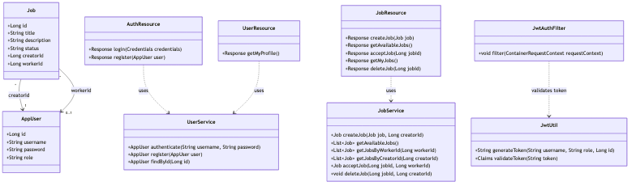
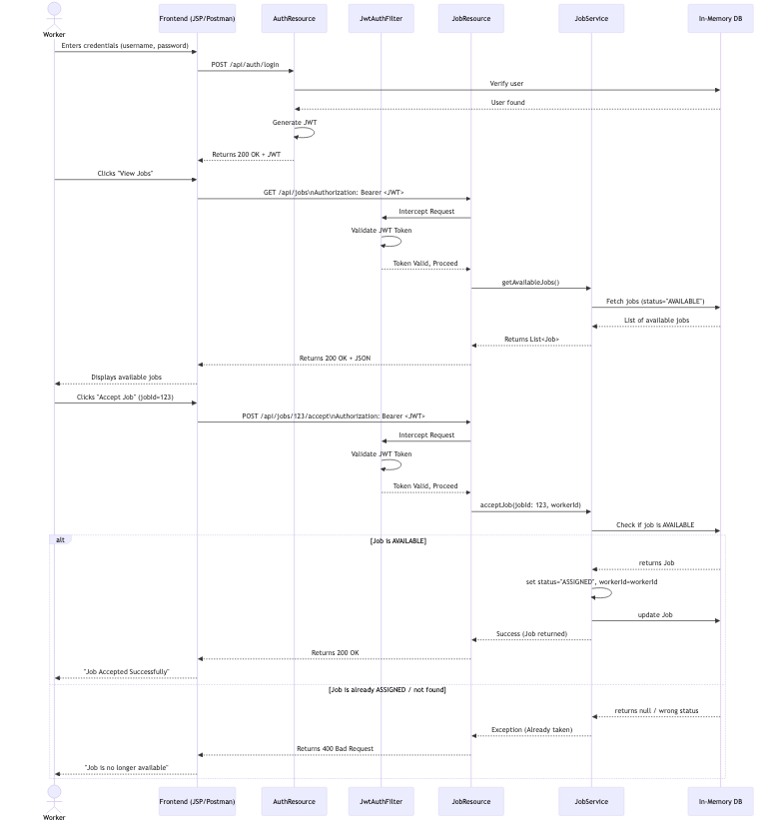

10. Screenshots
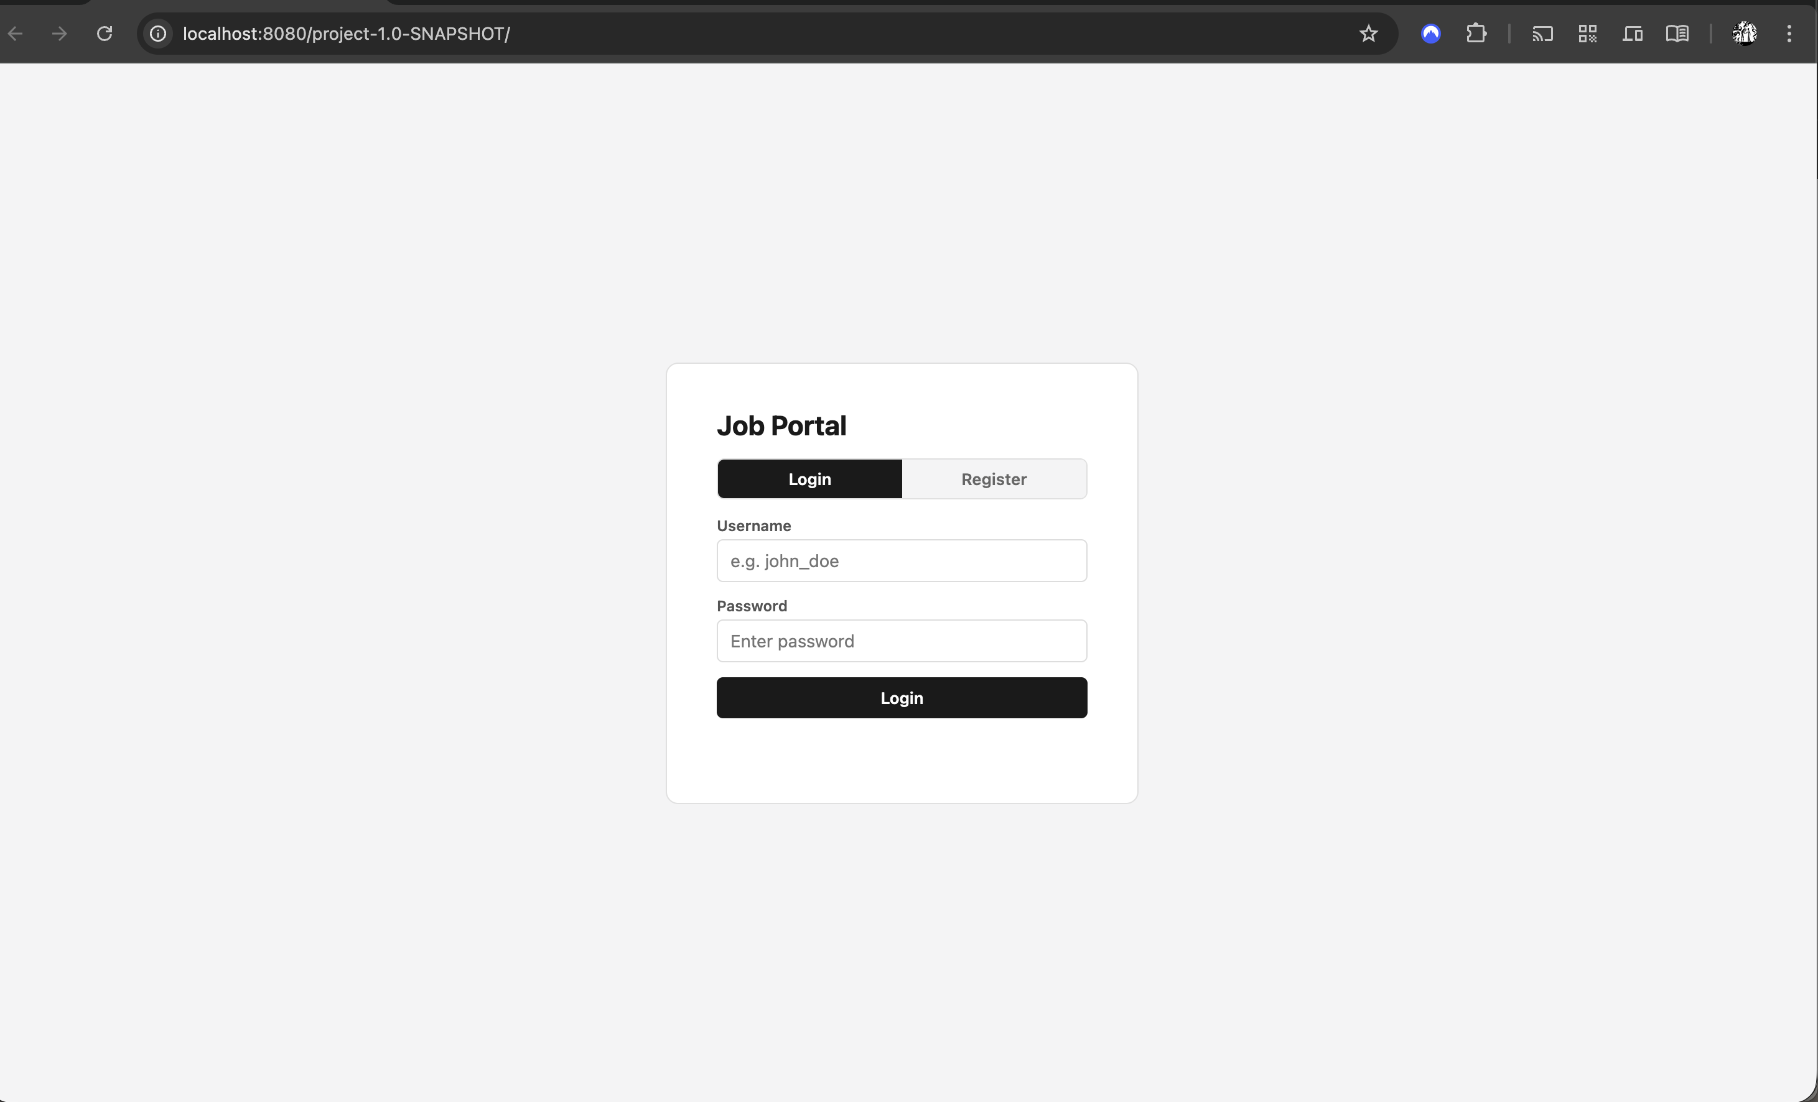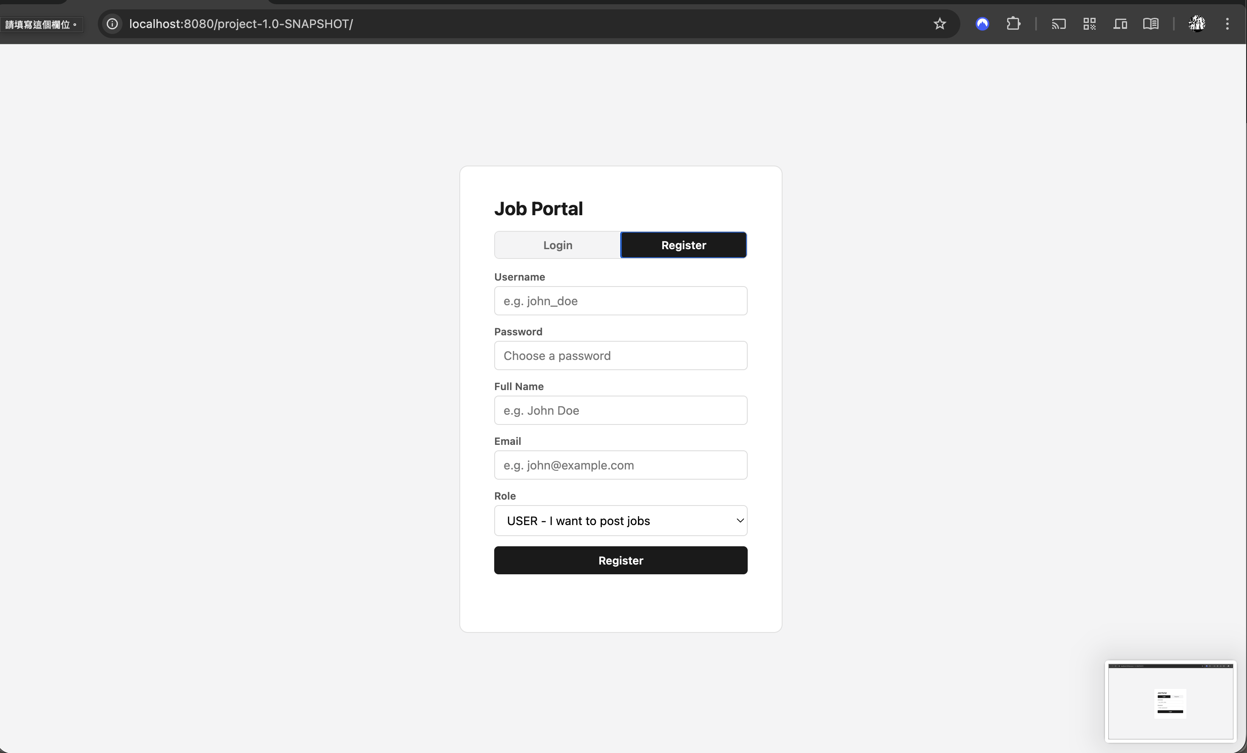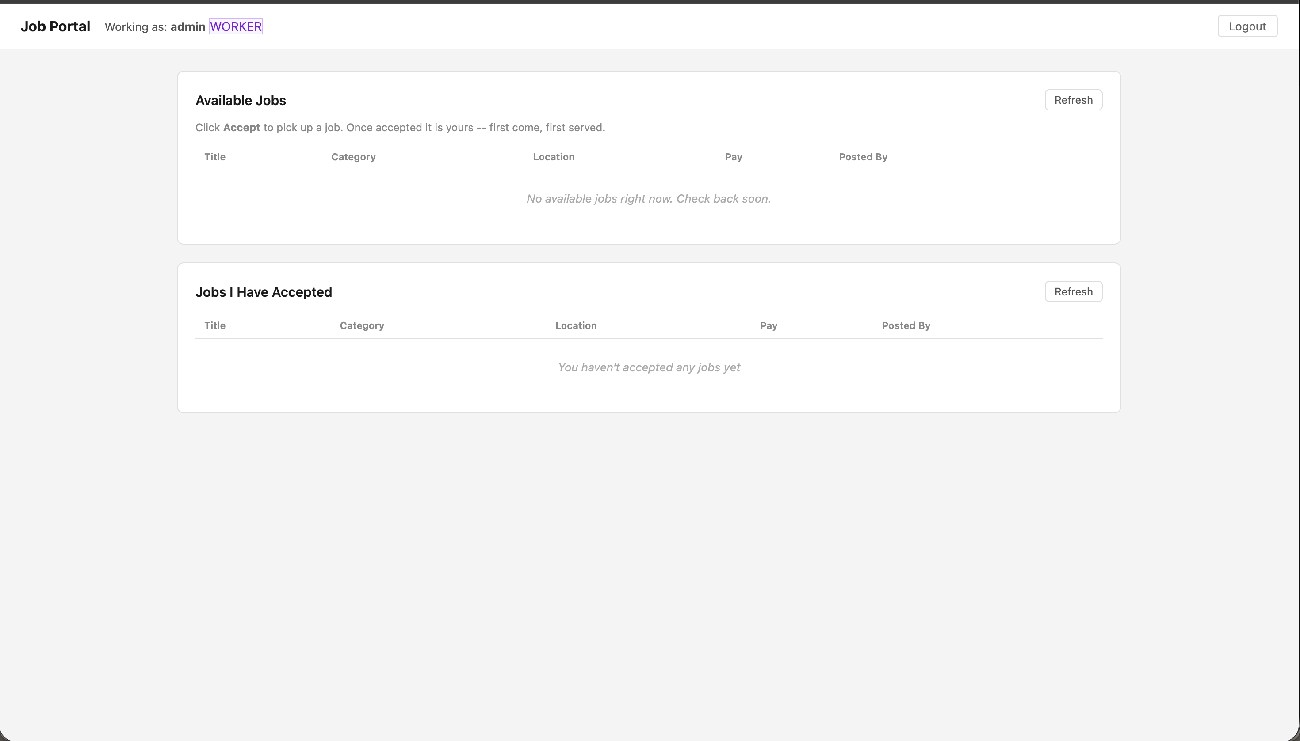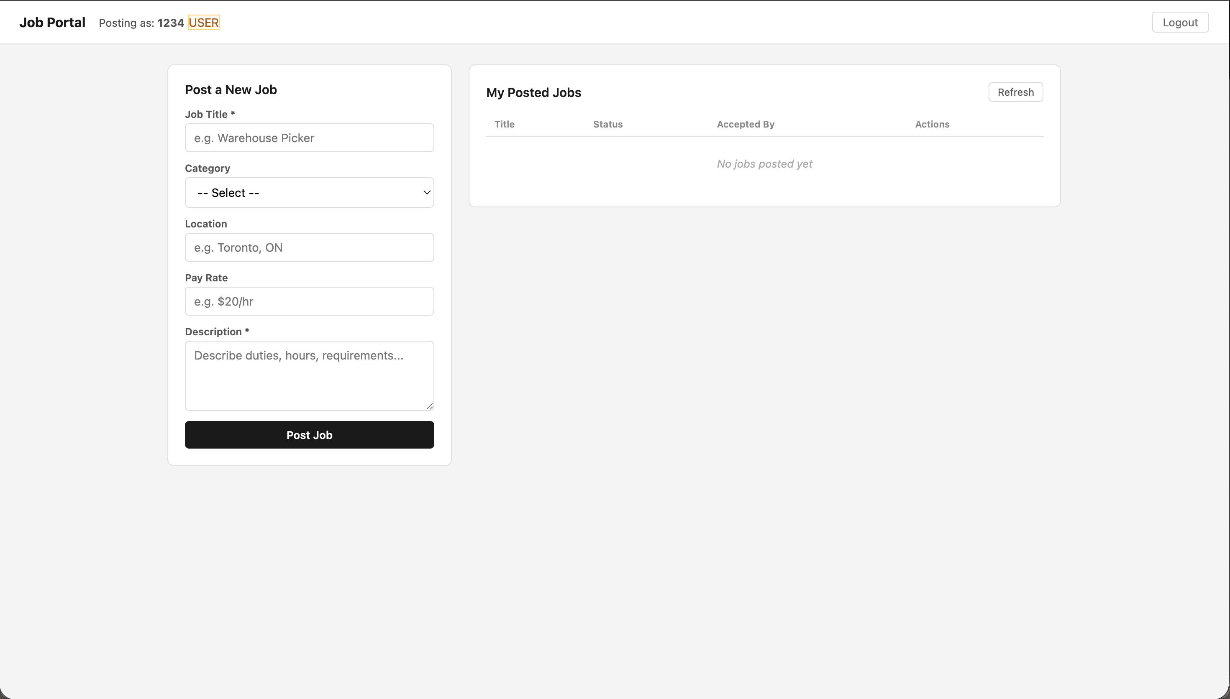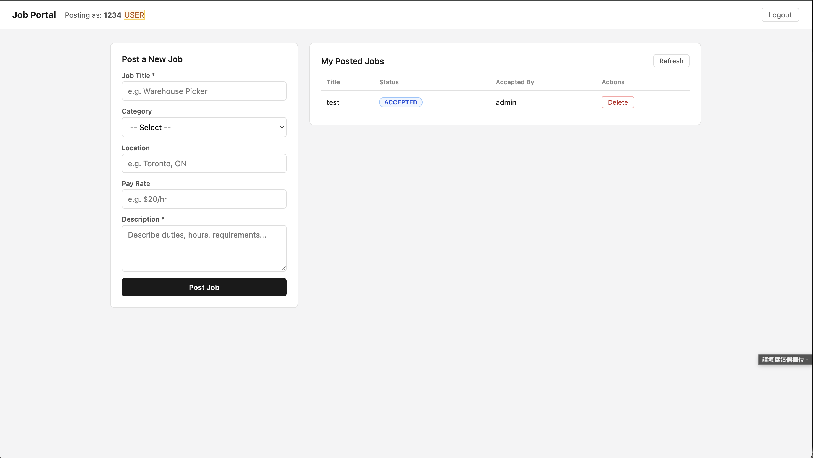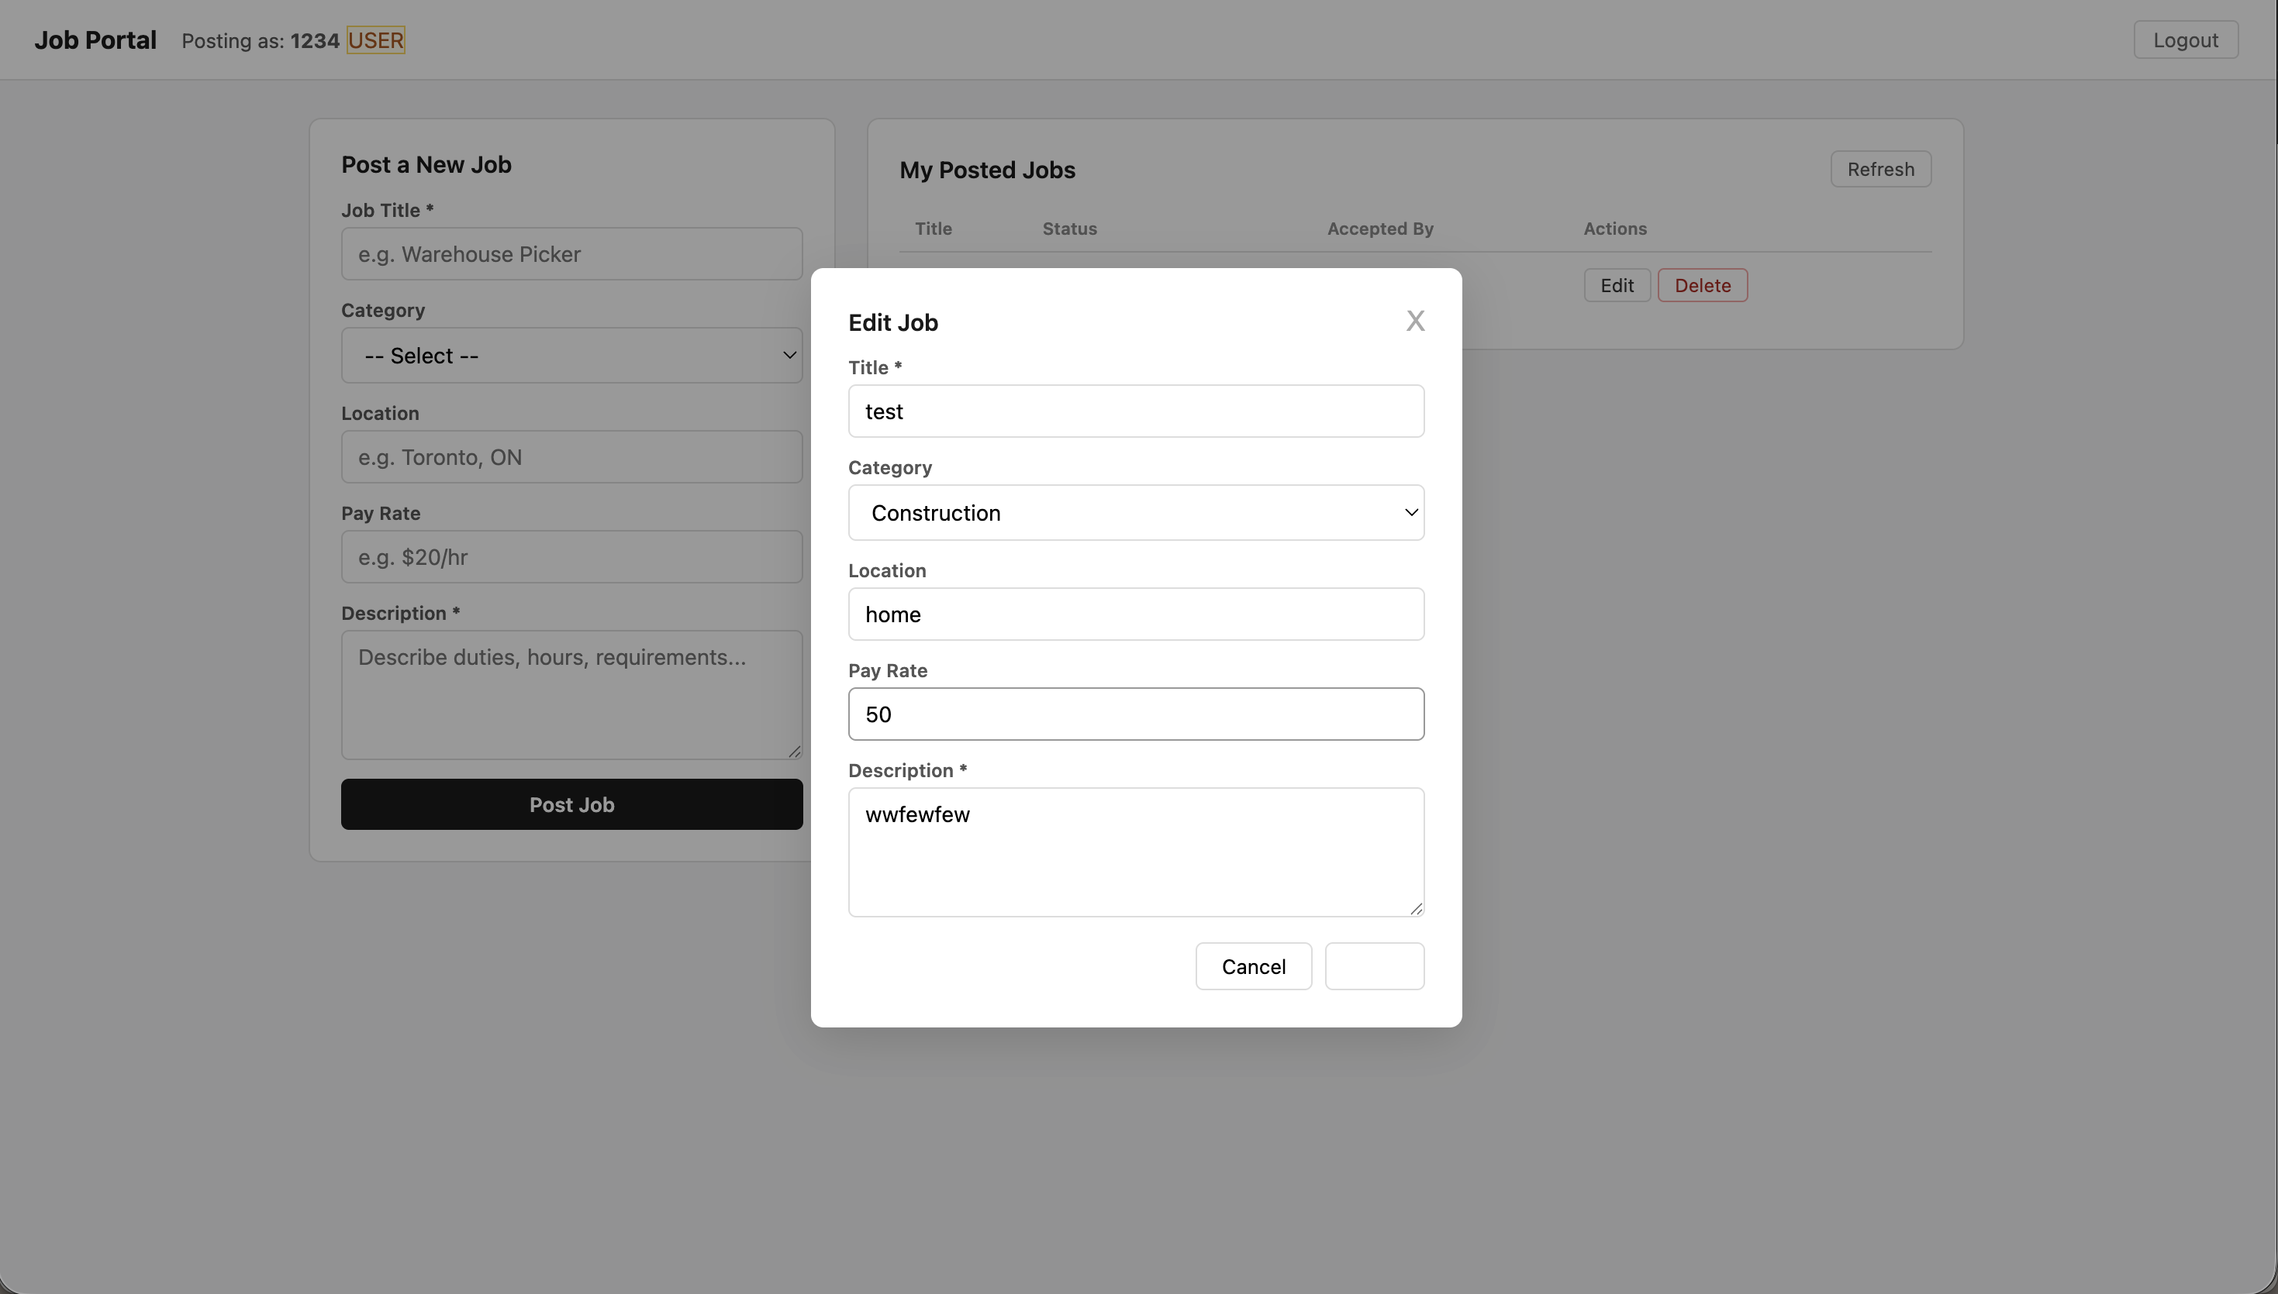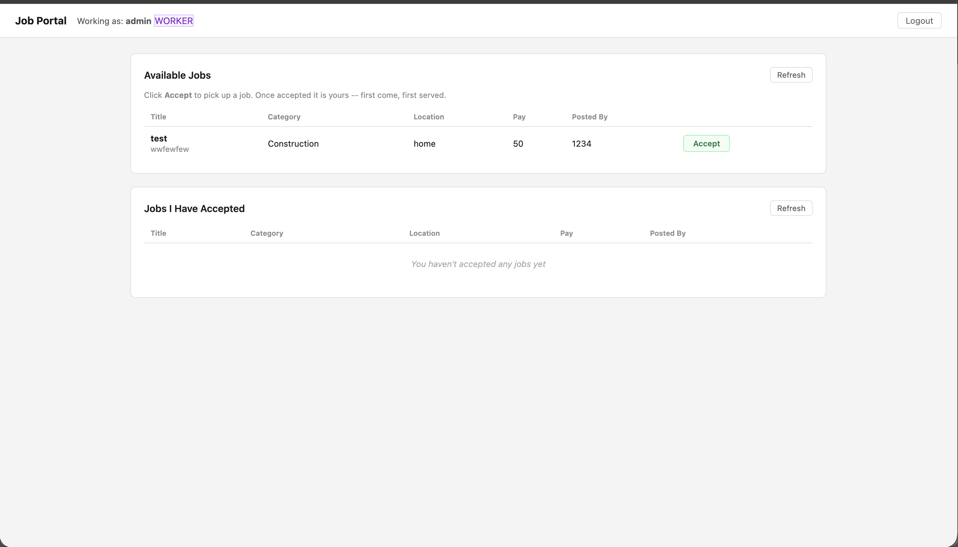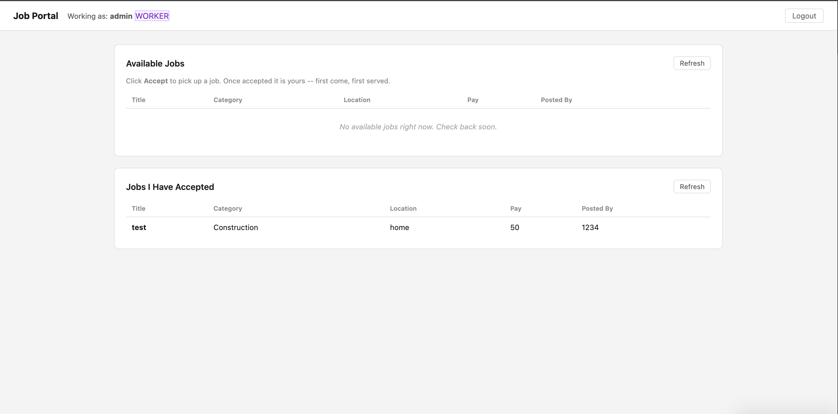
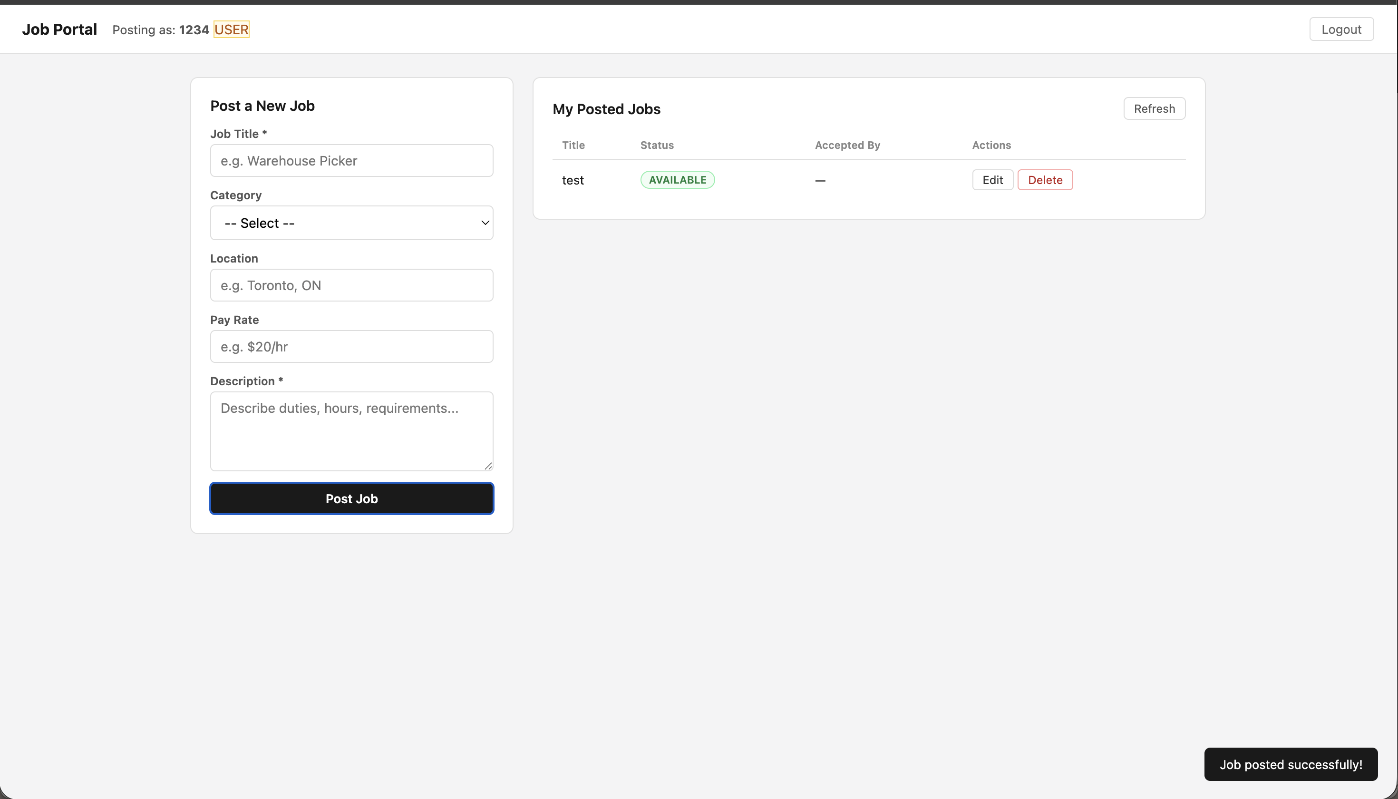

11. Testing
APIs exercised with Postman or similar using HTTP Basic (not JWT): public job reads; employer/worker/admin flows on protected routes.
Web UI: employer job lifecycle; worker apply and messaging; role separation on /employer/**, /worker/**, /admin/**.
Unauthorized API access returns 401 Unauthorized.

12. Conclusion
The Quick Job System demonstrates a Spring Boot stack with Thymeleaf web UI, JPA persistence on H2, role-based access control, REST APIs secured with HTTP Basic, and standalone deployment via Spring Boot (embedded server)—without EJB, WildFly, JSP, or JWT.

